EXPERIMENT 1

**Name : Urvashi Rathore**

**SAP ID : 500083262**

**Batch : Devops B1**

**AIM: Installing Vagrant & Creating basic vagrant box using Virtual Box virtualization.**

Steps to Complete:

1. Download and Install Oracle Virtual Box 5.x and Vagrant 2.2.7

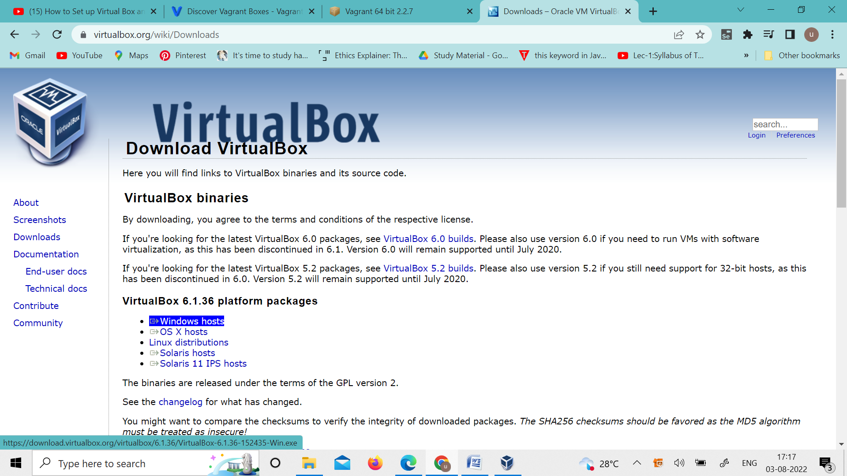

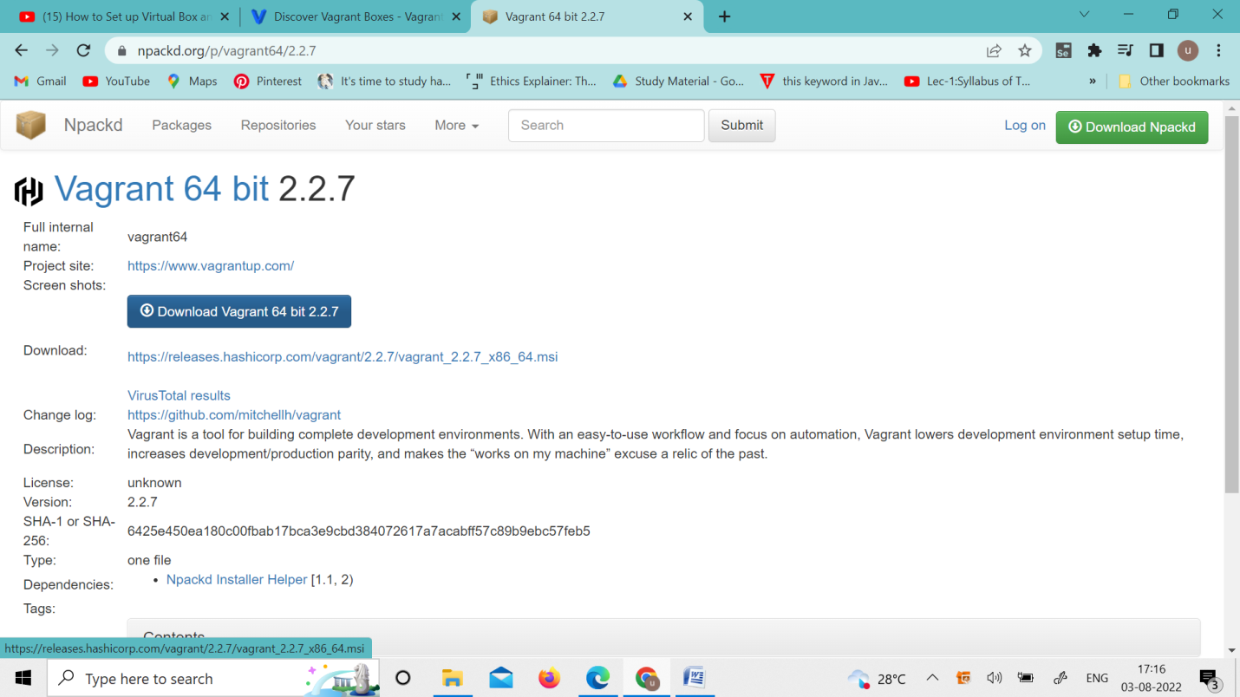

2. Check working of Vagrant using vagrant --version command.

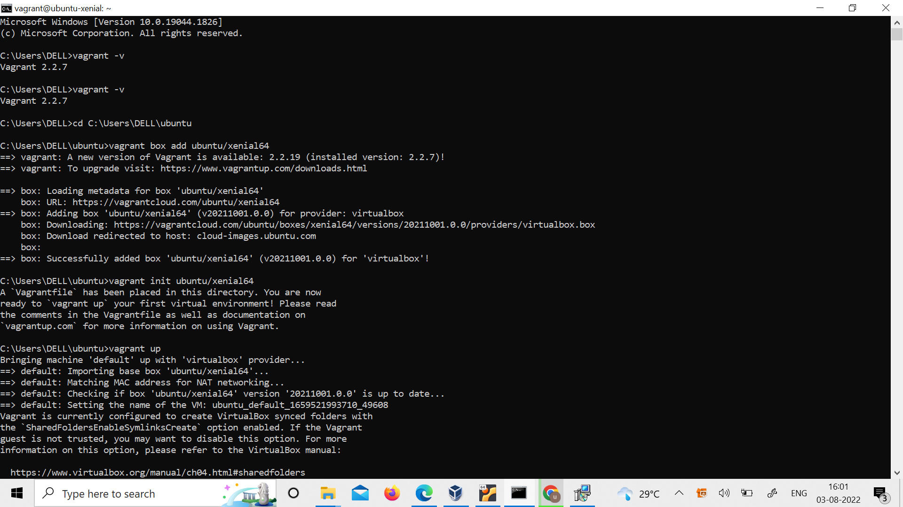

3. Create a new directory using CMD.



4. Run vagrant init command

5. Edit vagrantfile and add ubuntu/xenial64 in box tag.



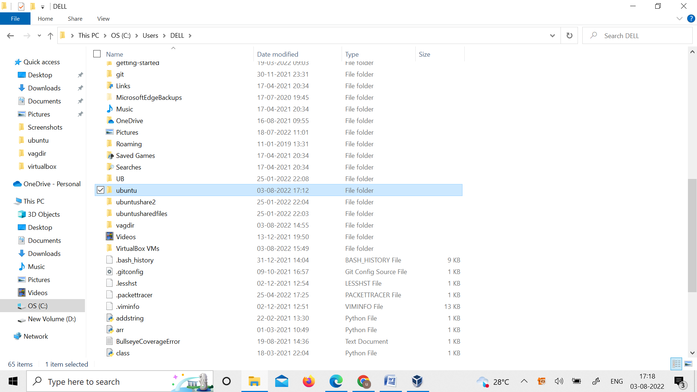

make vagrant file in the folder



6. Run vagrant up command

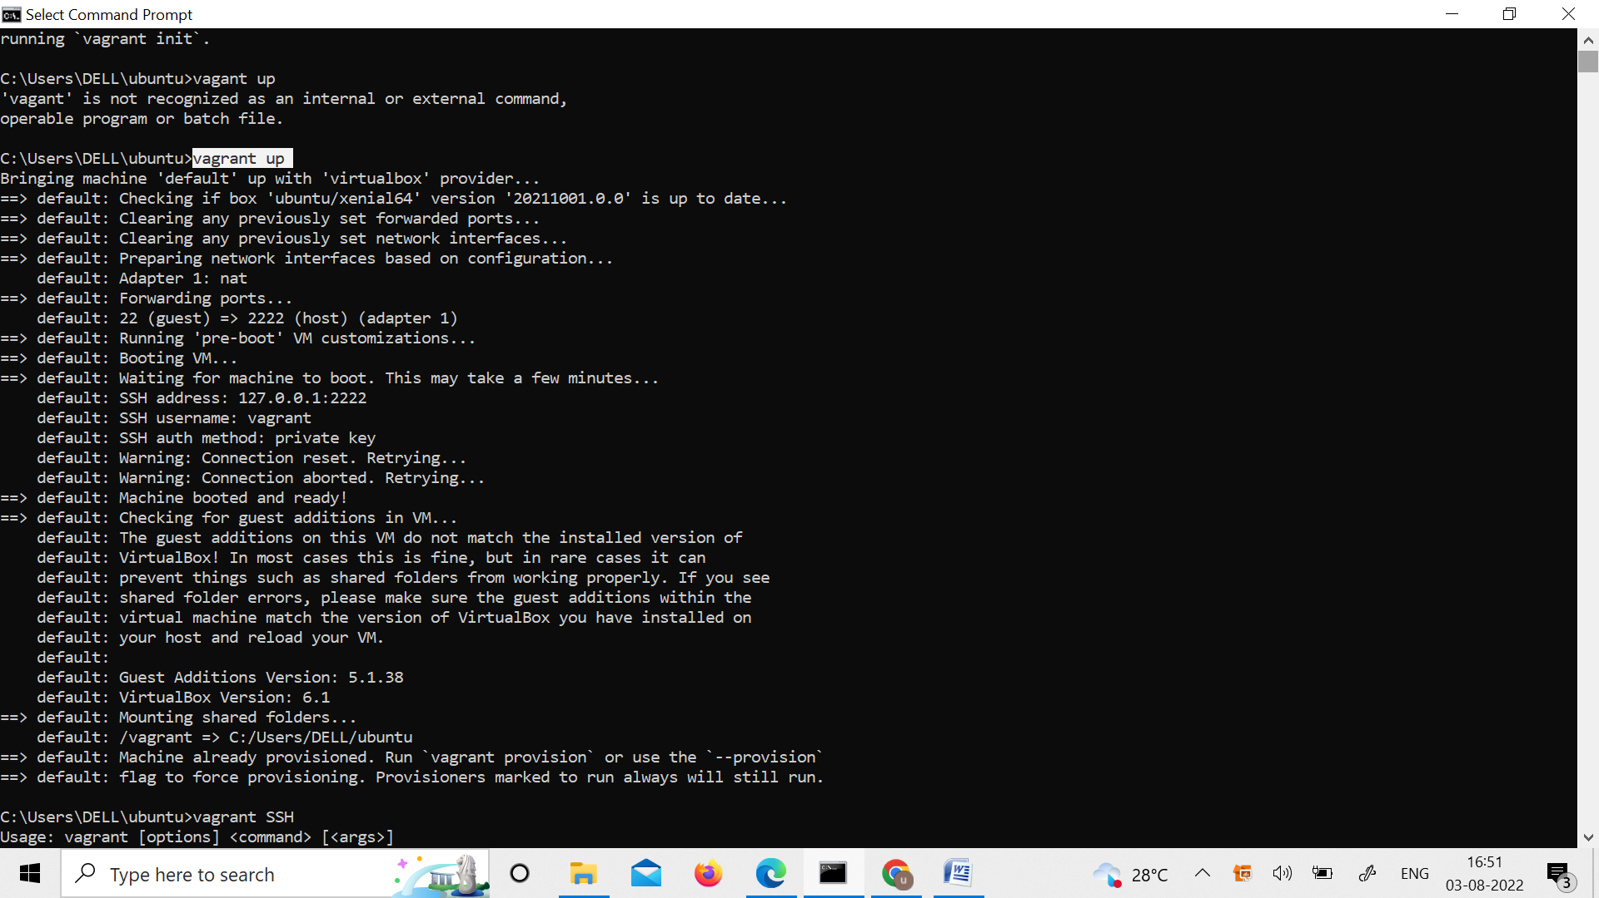

7. Run vagrant SSH command

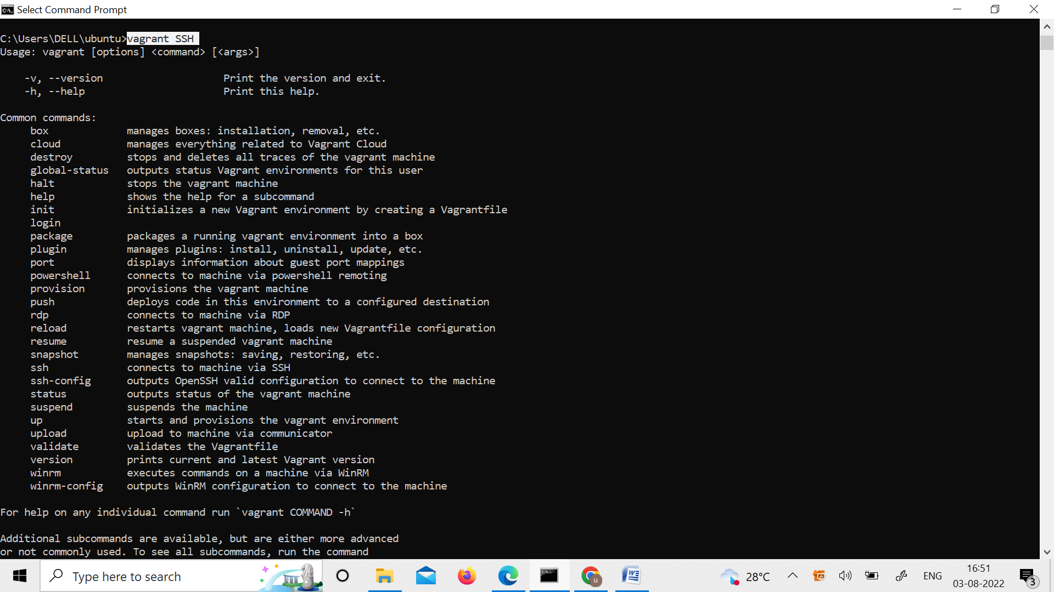

8. Run Vagrant Halt to stop VM

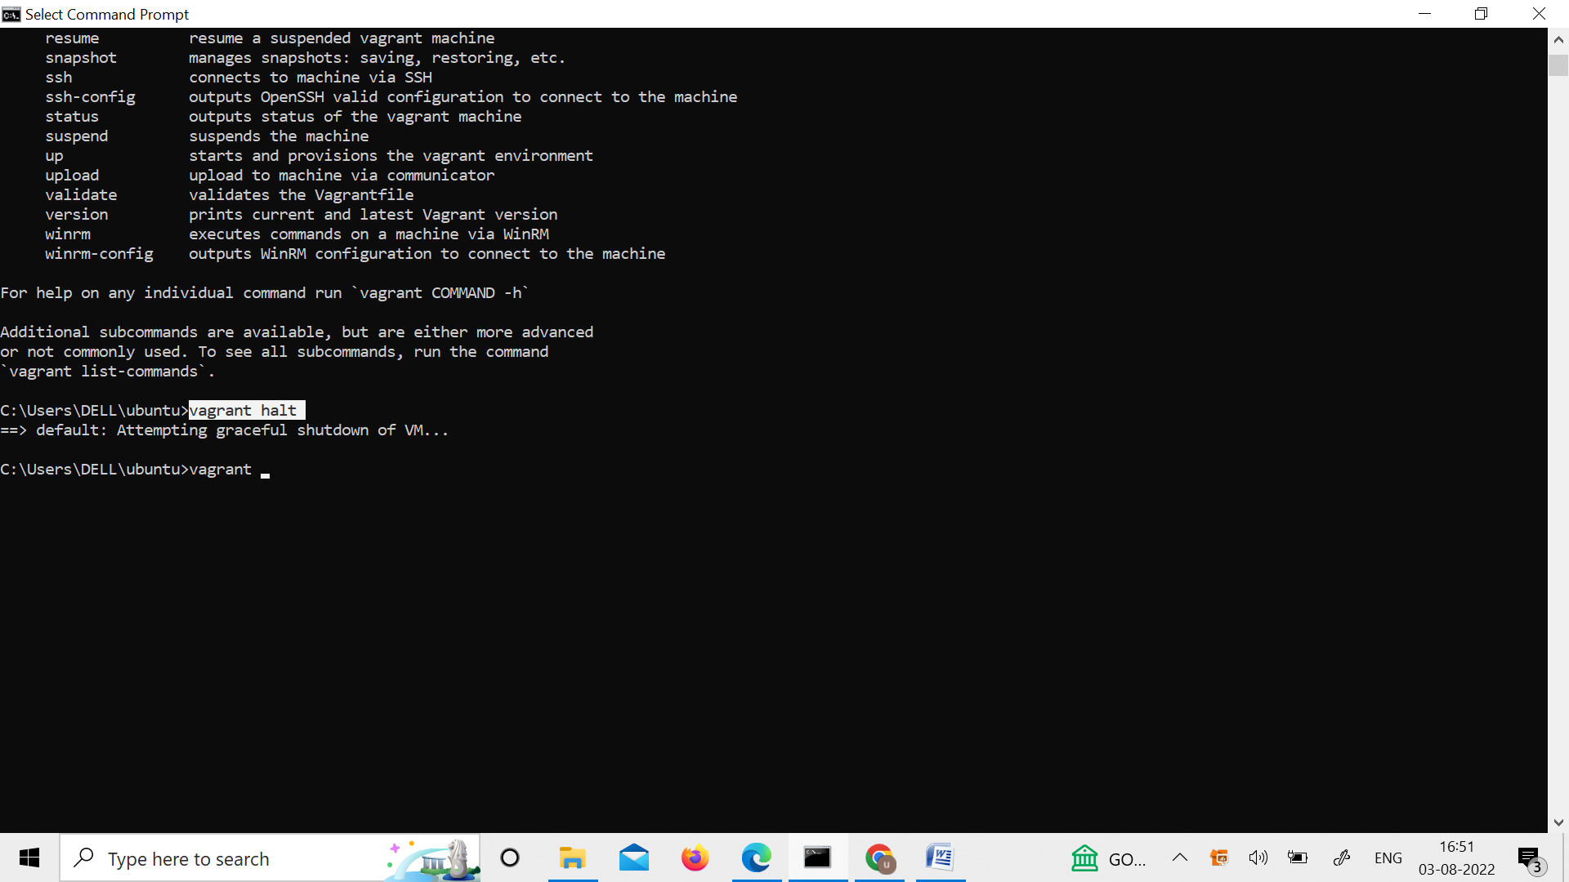

9. Run Vagrant Destroy to delete VM

